TOWN OF ORLEANS
COMMUNITY PRESERVATION COMMITTEE
AGENDA
August 7, 2025, 4:30 p.m.

The Community Preservation Committee will hold a meeting in the Nauset Room of Town Hall and via Zoom beginning at 4.30pm on August 7, 2025. Real-time public access will be provided by Orleans Channel 8 on the Town website and cable television.
Meeting: Community Preservation Committee
Join Webinar: https://us02web.zoom.us/j/84951375780
By Phone: (646) 558-8656 Webinar ID: 849 5137 5780

- Call to Order and welcome to new members.

- Public Comment.

- Comprehensive Plan update (E. Jenkins and Planning Board).

- F25 close and launch of FY26.

  - Grants and grant highlights
  - Review of invoicing procedures

- Vote to approve payment of annual dues to Community Preservation Coalition.

- Committee organization.

- Assignments and updates on projects as needed.
- Approval of Minutes: June 5, 2025.
- Adjourn.

Item 4

Procedures for processing CPA invoices.

The following procedures apply to both Town and non-profit grant recipients. Your Project Monitor/Liaison will assist you in reviewing the grant agreement, for additional requirements, if necessary.

- Invoices may be paid by the Town either directly to your contractor/vendor, or as reimbursement for funds that your organization, as the Grant Recipient, spends on approved expenses. You must indicate who will be paid CLEARLY on your Invoice Validation form.

- Payment requests.
Please provide your CPC Project Monitor/Liaison with the following documentation. (Please do NOT send it directly to the Finance Department.).
- Original invoice(s) – not photocopies or digital files, please.
A complete description of work completed, or supplies/equipment purchased are required.
- Invoice Validation form signed by you as Grant Recipient organization.
- You will be provided with an Invoice Validation form with the Town account number printed on the form. Be sure to clearly indicate if the payment will be made to your organization or the contractor/vendor directly.
- If, the Grant Recipient organization has multiple CPC grants, It is up to the Grant Recipient to ensure the invoice is attached to the appropriate Invoice Validation form. If you are uncertain, consult your Project Liaison for assistance.
- W-9 Form. A W-9 is needed to pay your organization, if requesting reimbursement; OR for each contractor/vendor, if requesting direct payment.

- Your Project Monitor/Liaison will review the invoice(s) for consistency with the project description in the Town Meeting article and the grant agreement. He or she signs the Invoice Validation Form to indicate approval and forwards the payment request to the CPC Chair. The Chair signs the Invoice Validation Form and forwards the complete payment request to the Town Finance Department. Advance payments cannot be made to vendors.

- Generally, the CPC Chair submits payment requests to the Finance Department by 10:00 a.m. on Thursday for payments to be issued the following Wednesday. Invoices missing one or more of the requested pieces of documentation will be delayed in processing.

- If delivery of supplies or equipment requires pre-payment to a vendor, you may want to ask whether a Town purchase order would be acceptable. The P.O. must go through the Project Monitor and be signed by the CPC Chair and Town Finance Director.

- Any questions regarding these procedures should be directed to the CPC Chair or the Project Monitor. The Chair will refer the question to the Finance Department if necessary.

Item 4
TOWN OF ORLEANS
COMMUNITY
19 SCHOOL ROAD ORLEANS MASSACHUSETTS 02653-3699 PRESERVATION COMMITTEE

FY2026 COMMUNITY PRESERVATION FUND
INVOICE VALIDATION FORM
Please complete this form and attach the invoice for payment by the town of Orleans.
PROJECT/GRANT: _________________________________date: ____________
CPA ACCOUNT NUMBER: 26991002 /59126 ?

invoice number: ___________ amount TO PAY: _____________________

name of RECIPIENT* for PAYMENT: ________________________________

i hereby certify that all goods or services related to this invoice have been received, that all charges pertain to the project name listed above, that the invoice has been checked for proper quantities, price and clerical accuracy, and that no request for funds are in excess of those applied for and approved by the community preservation committee. i further certify that payment has been made in full For all goods and services which were the basis of any prior invoices for this project.

grantee signature: _______________________________________________

CPC Project Monitor:_________________ CPC CHAIR:____________________
*A W-9 for the recipient must be on file with the Finance Department of the Town of Orleans for timely payment.

Item 4 a
The Community Preservation Committee (CPC} Grant Agreement
Important Points to Note :
The top portion of the grant agreement (before the numbered Terms & Conditions section) includes your organization’s name, the amount of the grant and what the CPC expects the grant to be used for. A description of how the grant may be used usually appears at the end of the last paragraph in this opening section.
Under the terms and conditions section, you will see numbered paragraphs with an underlined word at the beginning. Briefly, the important things to note are:
- Award – this is the amount of the award that was approved at the Town Meeting.
- Project – this is a description of the project and is based on the Town Meeting article’s description of the project. Your organization may not spend CPC funds against any costs that are not covered by this description or your original grant application.
- Terms - this section tells you whether you have one, two or more years to complete the work to meet the grant requirements. You must formally request an extension to this term, if needed, and you will need a signed agreement from the CPC, after a vote of approval, to extend the term.
- Appointment of CPC Member to Project -this section explains who your Project Liaison/Monitor is and advises that you should keep your Liaison promptly informed in writing about scheduling, actions, delays or the completion of the project.
- Budget – this section says the CPC should review a finalized budget prior to work beginning and be informed of any other grant givers or sources of funding.
- Disbursement – This section explains how to get reimbursed from the CPC after you have had work on your project done. You must submit an invoice AND an Invoice Validation Form to your Liaison for effective payment to be made.
- Reports – This section tells you to report in writing every six months at least about the progress of your project (even if nothing has happened). To comply with a CPC grant, you also must issue a final report with photos and documents at the conclusion of the project or arrange a site visit by some or all CPC members.
- There are sections requiring compliance with laws and the grant agreement; a commitment to obtain all necessary licenses and permits, and an indemnification of the Town from liability for your project.
- Awareness/Stipulations -there is a section, usually number 11, which advises your organization to work with the CPC to acknowledge the grant for your project either online or at your site.
- Assignment - there is a section that says you cannot pass the grant on to another organization.
- Entire Agreement – Importantly, this section says that any changes to what the grant agreement says must be restated in writing and agreed with the CPC and your organization. This includes using funds for other work or extending your grant’s time frame.
- Historic projects usually have a section (number 13 or 14) saying that your organization agrees to sign a Preservation Agreement, will link with the Orleans Historic Commission and will ensure preservation work aligns with the "The Secretary of the Interior's Standards for the Treatment of Historic Properties" (36 CFR 67 and 68).
- Signatures are generally required from the CPC and your organization’s top officials like Director, President and Treasurer or Secretary (or the equivalent).
Please feel free to ask your CPC Project Liaison for help or clarification with any part of this agreement or if you think something should be altered or updated.
The Financial Year for the CPC begins on July 1 and ends the following June 30th. It is vital to submit all invoices for your grant project on or before June 1 to ensure proper processing and payment.

Item 5
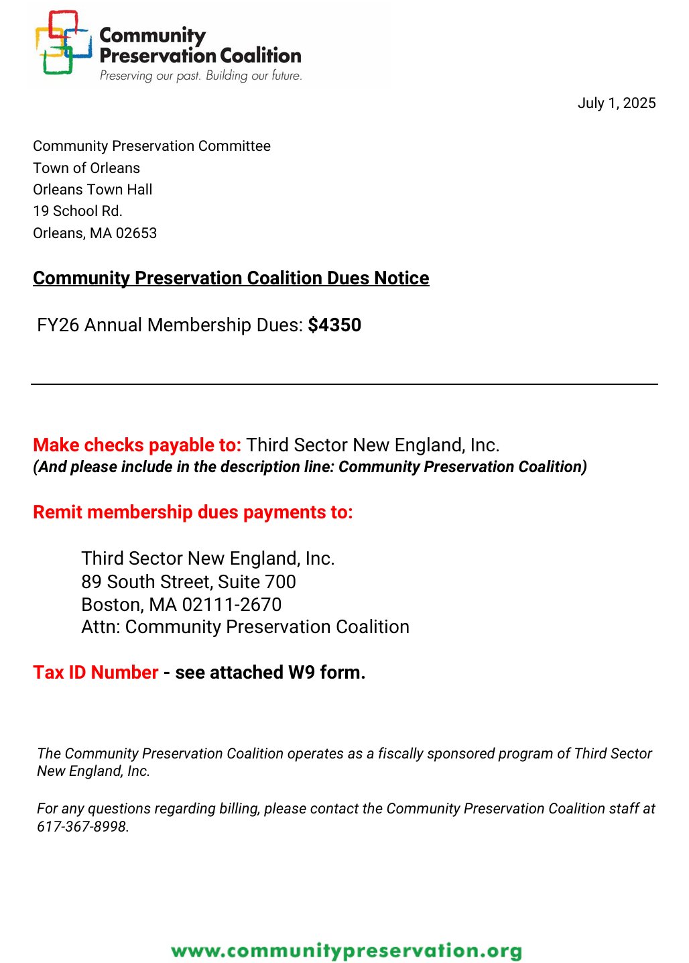
Item 7
July 2025 for FY26

Account code Project description Balance Liaison

59122 N (REC) Enhanced signage- trails $30,130.90 M Herman?
59122 P (HOU) Consensus Building for Aff. Housing $9050 J. Lipman
59123 H (HIS) French Cable rewiring/archival $12,053.25 S. Gaskill
59123 I (REC) Shared-use path (signage) $8805 S. Gaskill
59123 L (REC) COA garden walk restoration $17,150 R. Wilkinson
59124C (HOU) Juniper/Lawrence Rd Housing $20,000 J. Lipman
59124G (OS) Open Space admin funding $10,500 S. Gaskill
59124 J (HIS) Frech Cable exterior restor $4000 S. Gaskill
59124 N (HIS) NW Schoolhouse Invoices pending $14,658.43 J. Lipman
59125 F (HIS) Academy Invoices pending $20,740 J. Francolini
59125 G (HIS) Early Nauset archeology $25,000 C. Ellis
59125H (HOU) Spring Hill Brewster housing $120,000 J. Lipman
59125 I (HOU) Forward housing project for region $60,000 J. Lipman
59125 J (HIS) Form B documentation $15,100 C. Ellis
59125 K (REC) COA Garden walkway rehab $26,000 R. Wilkinson
59125 L (HIS) NW Schoolhouse kitchen inv pending $26,620 J. Lipman
59125 N (HIS) NW Schoolhouse overruns $11,000 J. Lipman
59125 E (HIS/REC) Veteran’s Park $150,000 R. Wilkinson

59126 (HIS) CHO protective structure for CG36500 $245,000 C. Ellis
59126 (HIS) OHC Form B document. Continued $25,000 C. Ellis
59126 (HIS) OHC Public awareness/signage $15,000 C. Ellis
59126 (HIS) French Cable sun shades $1,250 S. Gaskill
59126 (HIS) Academy Ph 4, Mansard roof, siding + $142,000 J. Francolini
59126 (HIS) NW Schoolhouse 1st floor restor/equip $95,030 J.Lipman
59126 (REC) Sipson Island signage $15,500 J. Lipman?
59126 (HOU) CDP Housing Inst. Workshops $10,000 J. Lipman
59126 (HOU) Aff Housing Trust -gen. funding $400,000 J. Lipman

Item 8
TOWN OF ORLEANS
COMMUNITY PRESERVATION COMMITTEE
MINUTES
June 5, 2025, 4:30 p.m.

The Community Preservation Committee (CPC) held a meeting in the Nauset Room of Town Hall and via Zoom beginning at 4.30pm on June 5, 2025. Real-time public access was provided by Orleans Channel 8 on the Town website and cable television.

Attending were Chair Walter North, Vice Chair Joan Francolini, Clerk John Lipman, incoming Select Board representative Michael Herman, Robert Wilkinson, Charles Ellis, Stephanie Gaskill with Francesca Galazzi attending via zoom. Mr. Alper was absent.

- Call to Order. The Chair called the meeting to order at 4.30pm.
Michael Herman was welcomed to the committee as member from the Select Board.
The Chair read out a letter of resignation from Barry Alper (attached below) and thanked him for his service and advocacy for affordable housing.

- Public Comment. No presented for Public Comment.

- Town meeting and warrant article debrief. Ms. Francolini recommended further description of projects in the Warrant Article to reduce the chance of confusion by the public.

- Committee organization and change of members. Mr. North said he would be resigning from the Conservation Commission so a new representative of that group will be appointed. Ms. Francolini will be the acting chair going forward. Ms. Gaskill said she was reaching her term limit on the Open Space Committee but is not yet sure if a new liaison will be appointed. She is willing to continue on CPC or serve as a member at large. Mr. Ellis shared the uncertainty on the Historic Commission with both Mr. Peterson and Ms. Nix resigning from that committee.
- Financial year-end close, encumbrances and invoicing procedures. The Chair reviewed the end of year processes including the documents for the FY26 group of Grant recipients. Ms. Gaskill explained that the Overland Way project still requires signage and the balance will be encumbered for that project. The Hardwired sign project also has a balance remaining which will be encumbered pending last minute follow up about invoice amounts. Some clarification of invoicing procedures with Town departments may be needed. The Veteran’s Park project has fully billed but an invoice or PO has not been sited. The Administrative Assistant will investigate.
- Update on projects as needed. Recreation would like to come to the CPC about Basketball courts in August or September. The Council on Aging Garden Walkway project has begun. The Veteran’s Park restoration has begun. The entire Early Nauset Archeologic project will be encumbered and continued next year. Some CHO invoicing is due shortly, the balances will be encumbered. There are open grants for the NW Schoolhouse to follow up on the status.
- Review of past grant giving. There was a discussion of Preservation Agreements with various 501-3c organizations and how that protects the historic or conservation interests of the Town. There was also some discussion of the strong history of giving to Affordable Housing projects and two major ongoing historic preservation projects.
- Approval of Minutes: March 6, 2025.
Ms. Francolini moved to approve the minutes of March 6, 2025. Mr. Lipman seconded the motion. Mr. Wilkinson, Mr. Lipman, Ms. Gaskill, Ms. Francolini, Mr. North, Mr. Ellis, and Ms. Galazzi voted Aye. Mr. Herman abstained from the vote. Motion carried: 7-0-1.
- Adjourn.

Ms. Gaskill moved to adjourn the meeting at approximately 5.45pm. Mr. Wilkinson seconded the motion. Mr. Wilkinson, Mr. Lipman, Ms. Gaskill, Ms. Francolini, Mr. North, Mr. Ellis, and Ms. Galazzi voted Aye. Mr. Herman abstained from the vote. Motion carried: 7-0-1.

Respectfully submitted,
Jennifer Fountain

ATTACHMENT for Item 7
TOP GRANT RECIPIENTS
Open Space ATM Category Amount
Purchase Conservation Restriction for Eli Rogers May 24 (FY25) Open Space $200,000
Greenbelt 66 Portmanimcut Lot 2 May 21 (FY22) Open Space $250,000
Cedar Pond parcels May 22 (FY23) OS $ 10,000
Acquire Peck property/Arey’s Pond May 21 (FY22) OS $775,000
61 Namequoit Rd May 16 (FY17) OS $ 74,000
Fleck property purchase May 12 (FY13) OS $120,000
Jackson property purchase (watershed) Oct 11 OS $ 54,000
Fleck conservation restriction May 10 OS $ 60,000
$1,543,000
OTHER:
Putnam Farm upgrades water/power May 22 (FY23) OS/Rec $71,250
Seacall Farm pasture restoration May 11 HIS $16,775
Seacall Farm orchard restoration May 10 HIS $14,935
Seacall Farm restoration May 08 HIS $29,463
Seacall Farm building restoration May 07 HIS $ 17, 095
Seacall restor/reg of Historic Places Oct 06 HIS $ 21,670
Miscellaneous funding for OS preacquisition multiple years
Housing/Affordable Housing Projects ATM Category Amount
FORWARD Ph II May 24(FY25) Housing $60,000
POAH/HAC Spring Rock Village Brewster May 24(FY25) Housing $120,000
POAH Juniper Hill Resid. at Lawrence Rd, Wellfleet May 23 Housing $20,000
HAC at 107 Main Street May 22(FY23) Housing $1mm bond
Pennrose West Rd May 21 (FY22) Housing $2mm bond
Campbell-Purcell Regional Housing Development May 19 (FY20) Housing $100,000
Homeless Prev. Council housing unit May 18(FY19) Housing $25,000
Homeless Prev. Council housing unit May 17 (FY18) Housing $135,000
Cape Cod Village May 16 (FY17) Housing $100,000
Emmaus House rehab of housing May 15 (FY16) Housing $25,049
Canal House May 14 (FY15) Housing $20,000
Cape Cod Village (autism) support w purch May 14 (FY15) Housing $350,000
Namskaket Rd Habitat housing May 14 (FY15) Housing $35,000
Rock Harbor Village Aug? 12(FY13) Housing $25,000
Namskaket Rd Housing July 12 (FY13) Housing $581,262
Hinckley Affordable Housing May 09 Housing $377,861
Route 6A Housing May 06 Housing $ 9,587 $4,983,759

AHTB/AHC general funding ATM Category Amount
AHTB general funding FY 25 May 24 Housing $400,000
AHTB Rental Assistance FY25 May 24 Housing $ 95,000
AHTB general funding FY24 May 23 Housing $500,000
AHTB general funding FY 23 May 22 Housing $500,000
AHTB general funding FY 22 May 21 Housing $500,000
AHC public outreach FY22 May 21 Housing $10,000
AHC education FY 21 Jun 20 Housing $5000
AHTB general Funding FY21 Jun 20 Housing $500,000
AHTB general funding FY 20 May 19 Housing $300,000
Affordable Housing Pre-Development Fund May 18(FY19) Housing $25,000
Housing Study May 16 (FY17) Housing $35,000
Replenish Housing fund May 12 $40,000
Replenish Housing fund May 09 Housing $14,000 $2,924,000
NWSchoolhouse/Oddfellows ATM Category Amount
NW Schoolhouse/Odd Fellows kitchen II fall2024/FY25 HIS 11,000
NW Schoolhouse/Odd Fellows kitchen II 2024/FY25 HIS 52,320
NW Schoolhouse/Odd Fellows kitchen 2023/FY24 HIS 128,265
NW Schoolhouse/Odd Fellows roof overrun 2022/FY23 HIS 3,320
NW Schoolhouse/Odd Fellows roof 2020/FY21 HIS 15,230
Odd Fellows Hall Building Preservation 2012 HIS 56,900
Odd Fellows Hall Building Preservation architect 2010/FY11 HIS 47,440
Odd Fellows Hall Building Preservation add work 2009/FY10 HIS 34,282
Odd Fellows Hall Building Pres basement/fire 2008/FY09 HIS 95,000
Odd Fellows Hall purch Preservation Restriction 2007/FY08 HIS 50,000
Odd Fellows Hall Building Pres. Water damage 2006/FY07 HIS 50,000 $543,847
Academy Playhouse
Academy of Perf -fire escape May 24 (FY25) HIS $ 25,000
Academy continue restoration May 23(FY24) HIS $128,265
Academy Playhouse Renovate/ Exp May 18 (FY19) HIS $250,000
Academy Playhouse heating system May 07 HIS $ 41,878
Academy stabilize foundation Oct 06 HIS $ 12,500
Academy design plans, fire suppression May 06 His $ 68,973
$ 526,616

CHO (OHS et al)
Plans for preservation of CG36500 May 23 (fy24) HIS $55,000
CHO Restore Hurd Chapel May 21 (FY22) HIS $132,000
Hurd Chapel Renovation/Relocation June 20 HIS $145,000
Meetinghouse ongoing preservation May 19 HIS $200,000
Meetinghouse storm windows May 13 (FY14) HIS $ 9,450
OHC archival preservation May 12 HIS $ 7,000
OHS doc/photo restor May 11 HIS $ 29,000
OHS land/septic survey May 11 HIS $ 1,200
Meetinghouse electrical work May 09 HIS $3,320
Restore CG36500 May 09 HIS $64,000
Meetinghouse electrical work May 08 HIS $4,570
Historic Society ledgers May 09 HIS $2,383
Historic interviews May 08 HIS $18,400
Meetinghouse books/artifact restoration May 07 HIS $ 4,792
Meetinghouse masterplan May 07 HIS $ 13,915
Oral History Oct 06 HIS $ 8,700
OHS Meetinghouse Oct 06 HIS $ 20,745
Historic Photo Archiving May 06 HIS $ 25,193
$ 744,668

French Cable Museum
Exterior restoration May 23 (FY24) HIS $36,750
Wiring, Windows and archive oldest material May 22 (FY23) HIS $35,670
French Cable Museum preservation of collection May 21 (FY22) HIS $31,810
Climate control system, Restoration June 20 (FY21) HIS $61,521
Database of artifacts, scanning May 19(FY20) HIS $31,625
$197,376

